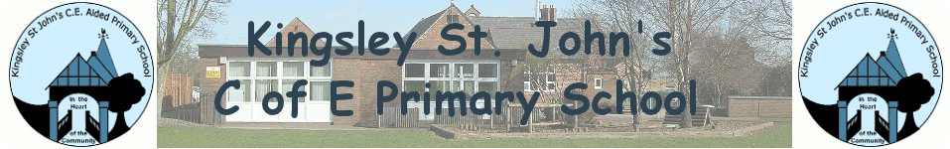

Love; Learn; Aspire; Achieve

PHONICS POLICY
Aims and Purpose

At Kingsley St John’s CE Primary school we strive to ensure that all children become competent readers and writers by the end of Key Stage 1.

• To benefit from a systematic approach to the teaching of phonics from entry to school
• To have regular access to high quality phonics teaching which secures the crucial skills of work recognition that enables children to read fluently, freeing them to concentrate on the meaning of the text
• To enjoy a multisensory approach to phonics ensuring the visual, auditory and kinaesthetic learning styles of children are engaged
• To encourage children to attempt to spell words for themselves, within the range of their subject knowledge, by building an individual repertoire and the confidence and strategies to attempt the unfamiliar
• To help children to use the skills of blending and segmenting in order to read and spell words Objectives
• To learn to read and write all 44 graphemes in the English language
• To teach children specific strategies to help them remember tricky words
• To blend and segment sounds for reading and spelling
• To apply their phonic knowledge across the curriculum Teaching and Learning

All phonics in EYFS and KS1 is taught following the Letters and Sounds document alongside a range of other programmes to create a multisensory approach; Jolly Phonics, PhonicsPlay and Bug Club.
We have adopted the suggested daily teaching sequence from Letters and Sounds; Revisit and Review, Teach, Practise, Apply.

From Reception to Year 2 children are streamed to allow the children to learn at their own pace; high achievers can make accelerated progress and those with additional needs gain further support.

Pupils who are not working at phase 6 of ‘Letters and Sounds’ by Key Stage 2 will be targeted in Years 3 and 4 for further phonics support.

Pupils from Year 3 onwards engage in daily Spelling, Punctuation and Grammar (SPAG) lessons.
Phonics teaching at Kingsley St John’s is multisensory, encompassing simultaneous visual, auditory and kinaesthetic activities to enliven core learning.

Phonics is taught in short, briskly paced session and then applied to reading and writing in a meaningful context. All classroom environments have an age appropriate display concentrating on sounds and key words.

At Kingsley St John’s CE Primary School we provide ample opportunities to reinforce and apply acquired phonic knowledge and skills across the curriculum and in such activities as shared guided reading and writing.

Assessment

Children’s progress in developing and applying their phonic knowledge is carefully assessed monitored. Teachers use daily phonics sessions to monitor children’s progress and adapt planning based on each day’s assessment.

Children are tracked individual and group assessment sheets at the end of every phase and within during phase 5. All staff in EYFS and KS1 have half termly moderation meetings to ensure all children are set appropriately and all assessments are accurate. Each week the children in Years 1 and 2 (and towards the end of EYFS for high achievers) are given spelling tests which focus on their chosen sounds of the week. The children are always given two ‘mystery spellings’ which require them to apply their phonic knowledge.

National Phonics Screening In addition in Year 1 children will take the phonics screening check. This assessment will confirm whether individual pupils have learnt phonic decoding to an appropriate standard. If a child does not reach the expected standard then additional support will be put into place in order for the child to make accelerated progress with their reading and writing. They will be retested in Year 2.

