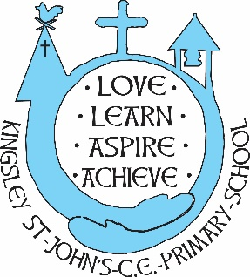

**TA Grade 4 17.5 hours per week 8.45am to 12.15pm**

The governing body of this Church of England Primary School wish to appoint a highly motivated and caring Teaching Assistant to support the teaching and learning of pupils in key stage 1. The position is for 17.5 hours per week, with a working pattern of Monday to Friday, 8.45 am– 12.15pm. This role will be a fixed 1-year contract at Grade 4, from January 2025 to July 2025 in the first instance, with a view to extending this to January 2026, if the funding is available. We need a Teaching Assistant who will adapt their skill to the specific learning needs of our children, working with consistency and in a nurturing, fun and caring manner.

Our school community places the highest priority on keeping our children safe. Applicants for the post will be subject to stringent vetting and induction processes including disqualification checks.

Closing Date for applications – 16th December 2024 at 3.00pm

Please complete the Diocese of Chester Application form to apply. References will need to be provided.