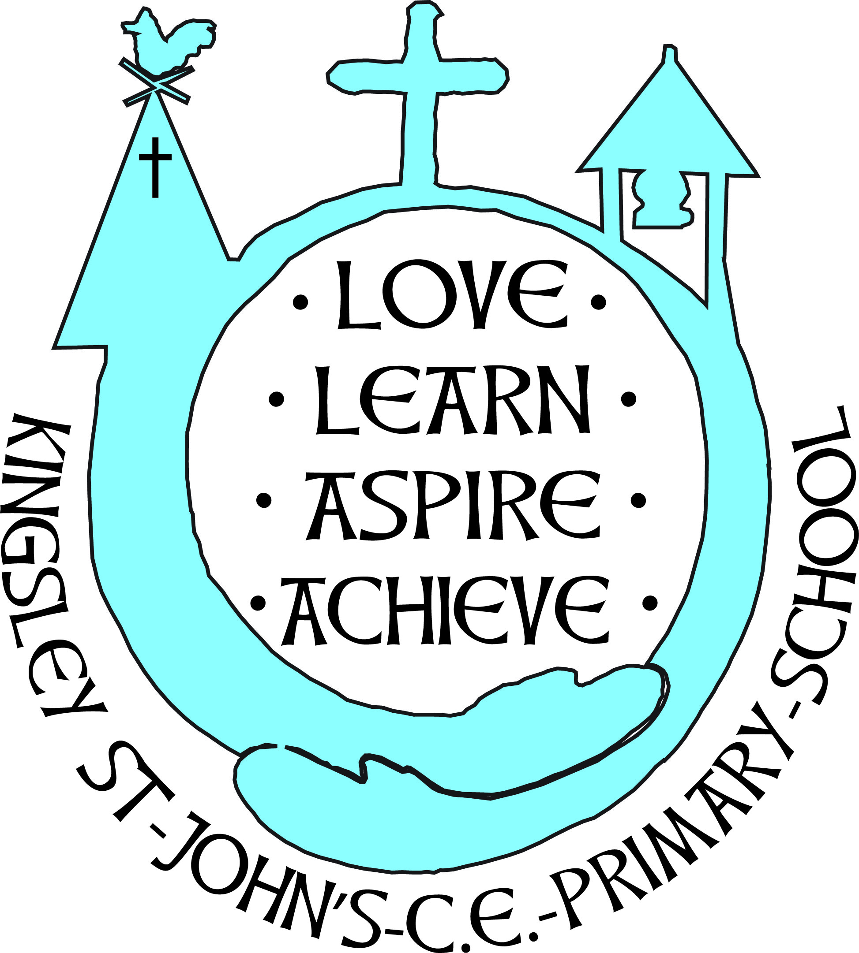 |  | Hollow Lane  Kingsley  Frodsham  Cheshire  WA6 8EF  Tel: 01244738434
Headteacher: Mrs R Jones | Email:  Email:  Website: | head@kingsley-st-johns.cheshire.sch.uk  kingsleystjohnsadmin@cheshirewestandchester.gov.uk  www.kingsley-st-johns.cheshire.sch.uk

Leith’s After School Club
To whom it may concern,
This letter is confirmation that Leith Rekbi will be carrying out his volunteer role for Silver Duke of Edinburgh Award at our school.
The after school club will be a table top games club for primary school children.
We are looking forward to supporting Leith with this endeavour.
Yours sincerely
Mrs Jones

