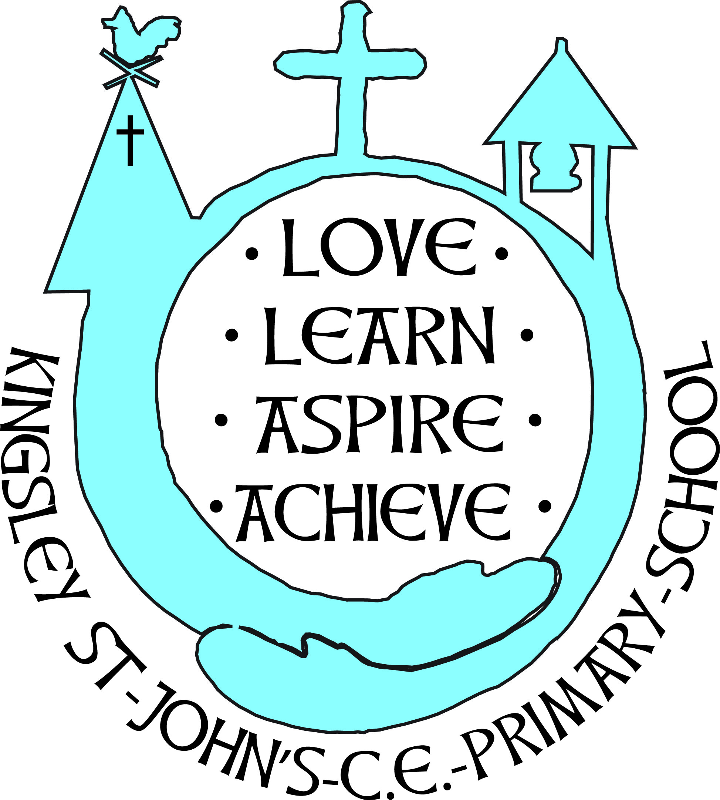 |  | Hollow Lane  Kingsley  Frodsham  Cheshire  WA6 8EF  Tel: 01244738434
Headteacher: Mrs R Jones | Email:  Email:  Website: | head@kingsley-st-johns.cheshire.sch.uk  kingsleystjohnsadmin@cheshirewestandchester.gov.uk  www.kingsley-st-johns.cheshire.sch.uk

Academy Conversion
Dear Parents/Carers,
It is approaching 2 years since we led a consultation with a proposal to convert to academy status with Chester Diocesan Academy Trust (CDAT.)
In that time there has been a significant amount of background research and financial forecasting.
As a small school, with unpredictable school numbers it is difficult to make close projections financially and this has caused a delay in our progress through the system. There was then the matter of the general election, which caused a further delay. We are now in the window for the next steps in this process.
I would like to take this opportunity to recall the consultation that we carried out in January 2023.
If you have any significant viewpoints or considerations regarding our application to convert, please email head@kingsley-st-johns.cheshire.sch.uk . It is hoped that we will be taking the final steps in converting to an academy in September 2025.
Yours sincerely
Mrs Jones

