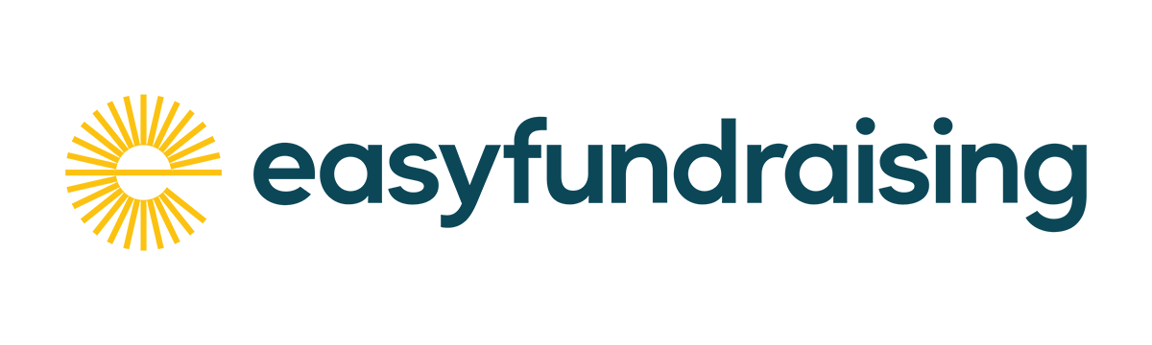
Did you know that whenever you buy anything online – from your weekly shop to your annual holiday – you could be raising free donations for Friends of Kingsley St Johns (KSJ) with easyfundraising?
There are over 8,000 brands on board ready to make a donation – including eBay, Argos, John Lewis, ASOS, Booking.com and M&S – and it won’t cost you a penny extra to help us raise funds.
All you need to do is:
1. Go to https://www.easyfundraising.org.uk/causes/fokstj/?utm_medium=email&utm_campaign=pmc&utm_content=gs-email1 or click on our QR code and join for free.
[insert QR code here]
2. Every time you shop online, go to easyfundraising first to find the site you want and start shopping.
3. After you’ve checked out, the brand will make a donation to Friends of KSJ at no extra cost to you whatsoever!
There are no catches or hidden charges and Friends of KSJ will be really grateful for your donations which are used to support the provision of facilities, opportunities and activities for all school children.
Thank you so much!

