‘Believe in the light, whilst you have the light so that you may become children of light’ (John 12:36) is our main aim for our children.
Love; Learn; Aspire Achieve
At the heart of everything is a personalised approach to each unique individual as part of our Christian Community. The strong family ethos ensures that all children feel valued and grow in self-confidence. Enthusiastic staff, with high expectations demonstrate care beyond the classroom. Through God’s guidance, we encourage his light in each and every child to discover their gifts and potential.
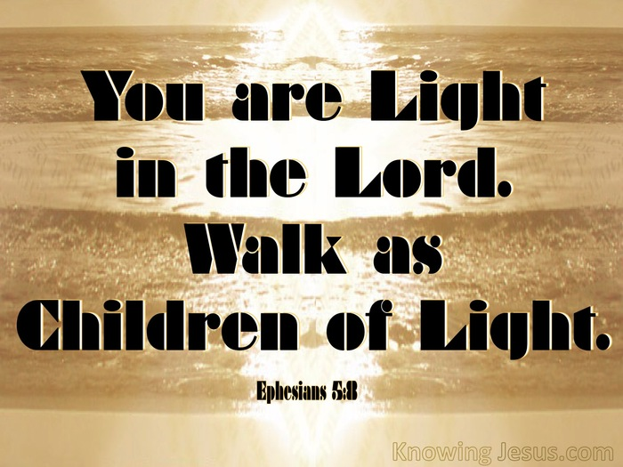
Interpreting John 10:10?
One of the final times that Jesus spoke publicly he said, ‘Believe in the light, whilst you have the light, so that you may become children of light.’ He meant – believe in him and his word, his actions – whilst he is alive, whilst he walks with them, whilst they have him, whilst they hear it from him. Then, when he is no longer on earth, no longer walking amongst them, they should become agents of light – spreading his word, sharing his stories and helping others live better lives.
Why John 10:10?
Many KSJers arrive as in-year transfers having met difficulty and barriers in their first educational environment. Developing self-worth, believing in them is paramount so that they can believe in themselves. We believe in every child in our school, we want them to believe in themselves just as confidently and in their peers too. Help others see their worth too.
What it means for KSJers.
We encourage our children to believe in God’s word, be Christians. Love, learn, aspire, achieve, learn about and believe in our Christian values whilst they are KSJers.
When they leave KSJ: at the end of the day, during holidays, to move on – be children of light. Take those values and live them out daily. Encourage others to do so – be agents of change. Use their gifts to make the world a better and more Christian world – Be children of light.
We blow out our candle to remind us that we are the light of the world
We light our candle to remind us that Jesus is the light of the world

