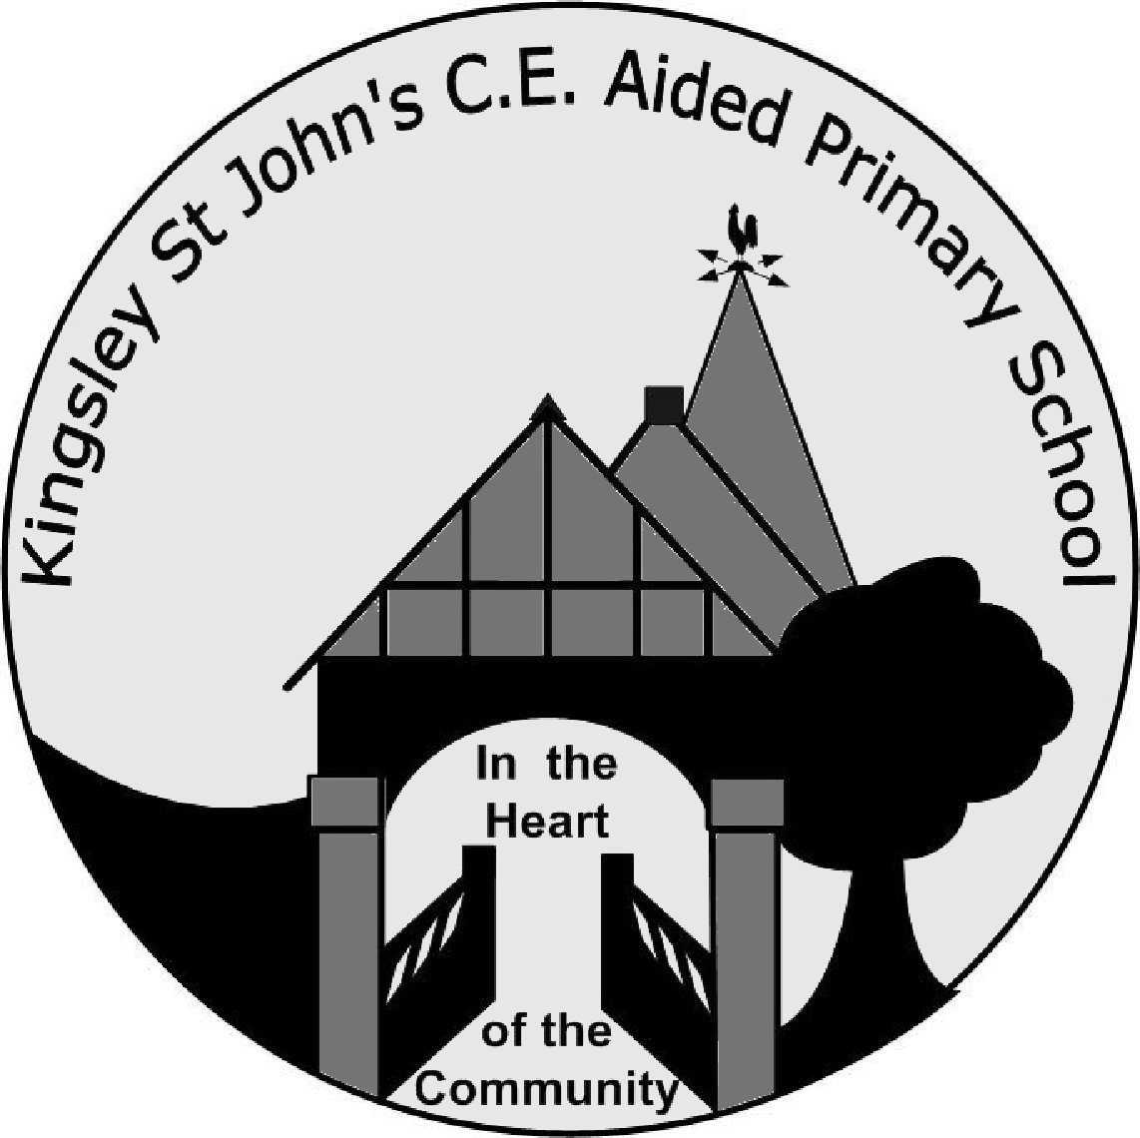 |  | Hollow Lane  Kingsley  Frodsham  Cheshire  WA6 8EF  Tel: (01928) 788536  Fax: (01928) 787600
Headteacher: Mrs R Jones | Email:  Email:  WebSite: | head@kingsley-st-johns.cheshire.sch.uk  kingsleystjohnsadmin@cheshirewestandchester.gov.uk  www.kingsley-st-johns.cheshire.sch.uk

23 March 2015

Dear Parents/Carers

Healthy School Status

Just a polite reminder that Kingsley St John’s is aiming to retain our healthy school status and as such we are encouraging our children to have healthy snacks at morning break.

Last year’s school council devised a list of healthy snacks to give to your children, including:

- Breadsticks
- Fresh fruit
- Raisins
- Apricots, dried fruit
- Rice cakes
- Flapjacks
Please could you help us in educating the children by not giving them chocolate or crisps for their
morning break.

Many thanks for your continued support.

Kind regards

Rachel Jones
Headteacher

